Hessett Parish Council

DRAFT MINUTES
Meeting held on Tuesday 25th July 2023 at 7.30 pm at Hessett & Beyton Village Hall.

Present: Councillors Phil Barrett, Tim Elliot, Andrew Pearson, Margaret Shaw, Debbie Willis

In attendance: Michelle Fisher (Clerk to the Council)

250723/01 Election of Chairman
Following the resignation of the outgoing Chair Cllr Margaret Shaw agreed to act as Chair for this meeting. It was unanimously agreed by the Parish Council.

250723/02 Signature of Acceptance of Office Forms
The Newly elected Chair signed Declarations of Acceptance of Office.

250723/03 Apologies
Councillor Stuart Turvill apologised for his absence having resigned from the post earlier than he had originally anticipated.

250723/04 Declarations of Interest
There were no Disclosable Pecuniary Interests Declared.
There were no other Disclosable Interests Declared.

250723/05 There were no Interests Declared.

250723/06 Minutes
The Minutes of the meeting of the Parish Council held on Tuesday 16th May were agreed to be a true record. The Chair was authorised to sign them as such.

250723/07 County & Borough Councillor Reports
Councillor Penny Otton explained that the library contract was up for renewal, and this included the mobile service. The library service would like to extend it and plan to do a consultation into the services required which would include what people want from the service and their knowledge of the services they provide. They hope that this will take place in October and that the Parish Council will take part.

Councillor Otton stated that her group made a Motion for speeding to make it easier for communities to apply for a reduction in their speed limit. Other councils have done a similar thing. Unfortunately, this was not agreed upon by the Administration at the County Council, and it was put to the vote and rejected without any discussion. Cllr Otton can still help Parish Councils to go through the process if they wish to have a reduction of speed limit in their village but warned its quite a bureaucratic process.

Councillor Willshire apologised for submitting her report late but was waiting for a few issues to be sorted first. Cllr Willshire highlighted various activities available over the summer holidays for families. Promises of things to be detailed in the next few months in her report and asking the council to let her know whether they have any questions and feedback.

250723/08 Public Forum
The members of the public present were here to discuss specific topics, namely, the Allotments and Speeding. As such the matter of allotments was brought forward to discuss for those members to be able to leave the meeting early following this discussion. The issue of speeding was dealt with next allowing for the speed watch representative to leave early.

250723/09 Allotments
The Clerk updated the Councillors on the Allotment Lease Holders and the Allotment Wait List. The Councillors asked the Clerk to chase those who have not responded to her correspondence. It was confirmed that some Allotment Lease holders would not be renewing their Lease and that therefore some Allotment plots were now free and would be offered to those on the list according to order of request.
The Councillors resolved to charge the following Annual Allotment rental rates:
- Quarter Plot £10.00
- Half Plot £20.00
- Full Plot £40.00
In the absence of an Allotment Officer, the Councillors approved a working group between Allotment Holders and the Parish Clerk to clarify Allotment sizes and zoning and to work with Allotment Holders to discuss any allotment matters arising. The Clerk is to report any matters to the Parish Council following these meetings.
The Council agreed that the Clerk should write to any allotment holders who appeared to be in breach of their lease when she visited the allotments, Pictures were taken, and these have been filed so an accurate record could be made.
The Council agreed that a tree report and quotes for further consideration should be obtained regarding the Allotment holder's request to have bushes and trees cut back.

The Allotment Lease Holders left the meeting.

250723/10 Speeding
The Council welcomed guest speaker Johnathon Shaw regarding Speeding in the
village and the use of AMPR and SID cameras. Mr Shaw explained that AMPR cameras have numberplate recognition, and he has 10 Devices that cover over 225 different sites. The Device would be put in the village for up to a week at a time. The Parish Council would need to complete a proforma and SCC would pay. There would be a charge of £120 for a post. If Hessett required two posts, they would pay for the other one. Mr Shaw recommended that the Parish council also purchase a SID camera as it was likely that the AMPR camera would only be in place every 6 months. A SID camera would cost £2,000 -3,000 to purchase.

Mr Shaw explained that Camera posts would not be available until October. The Councillors asked the Clerk to research whether CIL funds could be used to pay for a SID camera and other possible funding available to the Parish Council. It was agreed that this item should be put on the agenda for the next meeting for further discussion.
The Councillors agreed to consider where to have a post put up for a speed camera. The Clerk is to confirm whether the Greens Act prohibits a post being put up for this purpose. It was the consensus of the PC that this would be the case, but they wanted to double-check. The PC would need to consider a suitable area away from overhanging trees and bushes which may obscure the camera and reduce effectiveness. The position of any post would be discussed at the next meeting.

250723/11 Planning
Decision Notice – DC/23/02462
Paddock Apple View, The Green, Hessett, Suffolk, IP309BE
Erection of Single Storey side/rear extension.
Notice that Planning Permission had been granted based on the plans.
submitted and that the development shall be begun not later than the expiration of three years from the date of permission.

250723/12 Clerk's Report & Administrative Duties
The Clerk advised that no decisions had been made under delegated powers since the last meeting.

The Clerk advised that she had continued to receive correspondence regarding the Church Footpath. Initial response emails were sent confirming receipt and thanking for bringing it to the PC's attention.

The Clerk advised that she had received complaints regarding dogs being off lead and not under full control on the Church Footpath and asked that this be included on the next agenda.

The Clerk explained that she had been asked by two PC members to add the current misspelling of the Hessett email address: hessetpc@gmail.com to the agenda. The Clerk explained that it is recommended by NALC that all Parish Councils move to a.gov.uk email address for security reasons. The Clerk collected some quotes for this from two providers:

Suffolk Cloud
Domain Name – 1yr £85/2yr £150
10 mailboxes at 1GB each – 1yr £120/2yr £200
10 mailboxes at 2GB each – 1yr £160/2yrs £300

Freethought
Domain name £120 every 2 years (inc VAT) and then hosting £73.50 every 2 years. This includes mailboxes for Councillors and Clerk.

The Councillors resolved to go with the cheaper quote from Freethought with a domain of hessettparishcouncil.gov.uk should it still be available at the cost of £120 + £73.50 totalling £193.50 every 2 years.

250723/13 Telephone Kiosk
Cllr Debbie Willis reported that there had been no changes to the telephone kiosk since the last meeting. Finding volunteers to help continued to be an issue and was stilting progress.

250723/14 Lawn Mower
Councillor Andrew Pearson confirmed that the lawn mower was unrepairable, and the Council resolved to purchase a new one. The outgoing Clerk had confirmed a budget of £500 had been set aside for this during the Parish Council Meeting in May 2023.

250723/15 Playground & Football Pitch Benches
Following correspondence received by the Clerk regarding the previously agreed removal of benches from the Village Green and by the Millennium Tree, the Council resolved to remove the old broken bench from these areas. The Clerk explained that the bench by the football pitch had concrete feet so this may make removal more difficult. The Clerk asked whether a fund should be agreed to remove the benches as it appeared that one had not been historically agreed. Councillor Andrew Pearson stated that he would arrange removal over the following days and the council resolved this decision.

The Council agreed that a check on the playground equipment should take place at regular intervals and that some new equipment should be considered. It was agreed that the possible purchase of new equipment would be put on the agenda for the next meeting.

250723/16 Church Footpath
Following the ongoing numerous complaints regarding the church footpath, the Parish Council discussed whether any progress had been made regarding keeping this footpath better maintained and whether further steps needed to be taken by the Parish Council to further aid this. The Clerk confirmed that progressive steps had been made towards a more permanent resolution to this issue:
The Clerk had asked T&MJ to attend to cut the grass and asked for his assessment of the situation and how things may be better maintained. This information was shared with the Estate Manager and SCC Footpaths officer.
The Estate manager had contacted the Clerk and confirmed that they would be
cutting back the hedges over the next few weeks following harvest. They confirmed that they cut back hedges around this time and operate around nesting season. They asked that the Parish Council please contact them if any issues arise and then they will deal with them as quickly as possible.
The Clerk has been in correspondence with Ken Larcombe, the Area Rights of
Way officer, Growth, Highways and Infrastructure Directorate at Suffolk County Council. He has visited the area and wrote to all parties concerned with suggestions. He is also looking into why the Parish Council needed a contractor when SCC had a contractor who was to cut the grass. He was going to discuss the issues with his manager and get back to the PC.

250723/17 Finance & Governance
Receipts & Payments - The Council reviewed the Schedule of Receipts and Payments prepared by the clerk and resolved to approve the payments (Details in table below).

The Councillors and clerk confirmed that internet banking had now been set up. Councillors were to start making secure Electronic Banking payments using the Dual authorisation system.

The Council resolved to pay the Clerk by bank transfer using a dual authorisation system moving forward instead of monthly by Standing Order.

The Council resolved to purchase a new Hessett Parish Council Laptop for the Clerk to use with an agreed budget of £500, with an additional contingency of £100 for software if required.

The Council agreed for the Clerk to look into SALC doing Payroll for a nominal monthly fee.

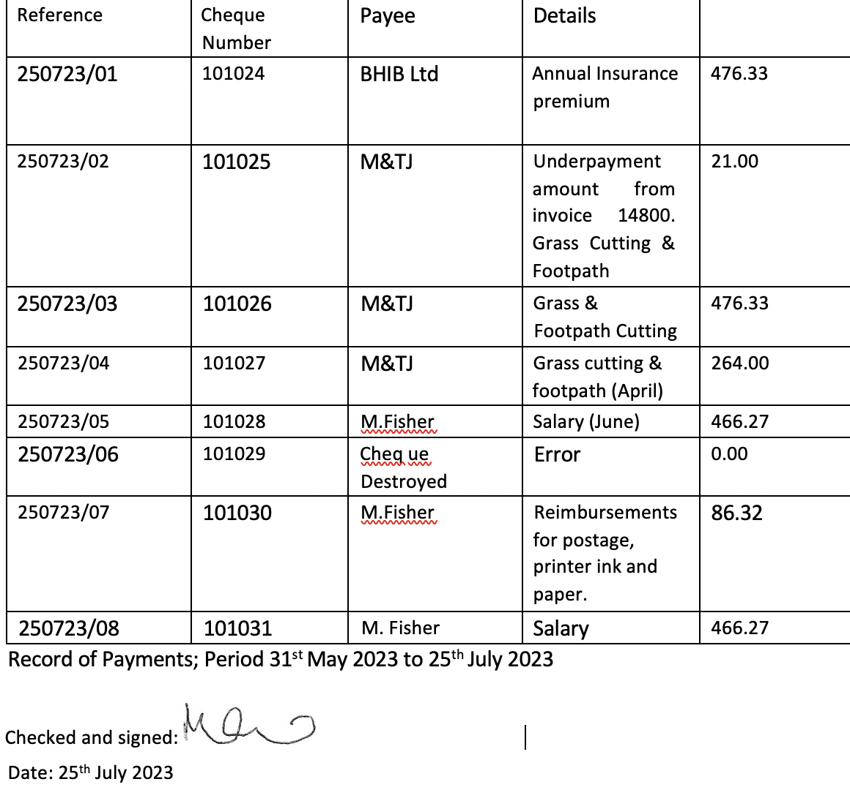

250723/18
The Council agreed for the Clerk to communicate with a Parish Resident which
the council had previously agreed not to respond to due to vexatious behaviour towards the outgoing Clerk. The Council agreed on the basis that should this person become an issue moving forward we would revisit this decision.

250723/19 Councillors' Reports and Items for Future Agendas
Councillor Debbie Willis and Cllr Margaret Shaw have money from the sale of the Coronation Mugs. 25 Mugs remain which Debbie Willis will take to the next coffee morning to see if any additional sell. If the mugs are not sold after this, they will place an advert in the next Parish Magazine asking whether anyone wants one. Cllr Tim Elliot to provide the contact details of the Parish Magazine to the Parish Clerk.

Cllr Andrew Pearson confirmed his attendance at the Highways event in Stowmarket regarding the A14 roadworks. On voicing his concerns, he was asked to put them into an email which he did, he will forward the Parish Council any response.

Cllr Debbie Willis confirmed her attendance at a Village Hall Meeting where they discussed a welcome letter/booklet for new people coming into the village. Could this be added to the agenda to discuss next time as we should have something in place?

Cllr Debbie Willis informed the Parish Council that there was some coffee
mornings set up that she will be attending.

The Council agreed the following items should be added to the next meeting Agenda:
- Speeding
- Allotments
- New Playground Equipment
- New Residents Information Letter/Booklet

The Next Parish Council Meeting is set for 26th September 2023 at 7.30pm

The Chairman closed the meeting at 10.30pm

Signed as a true record by authority of the Council
Chair
Date

