Parish Report – February 2025
Councillor Nicky Willshere Email: Nicky.Willshere@Midsuffolk.gov.uk
Rattlesden Ward Mobile: 07793610542

Devolution
A joint extraordinary meeting of Mid Suffolk and Babergh councils will be held 10 February to hear the outcome of Ministerial decision in response to Suffolk County’s request to be considered for early unitary status.

Local Nature Recovery Strategy
A public consultation is about to be underway (March 2025)
This is a joint Suffolk and Norfolk strategy being tabled. The Environment Act 2021 sets out new legislation that requires the production of new spatial strategies for nature recovery called Local Nature Recovery Strategies.

The LNRS will also be used to:
• provide information to farmers and land managers to help them choose
which Countryside Stewardship and Sustainable Farming Incentive options
are appropriate for their land
• help groups of farmers and land managers shape nature recovery priorities
for their area, and to encourage collaboration across holdings and landscapes
• identify opportunities for Landscape Recovery project proposals, and to
provide evidence to support their application and project development
• help Government when considering applications for funding for specific
nature recovery activities, by acting as criteria in applications
• help responsible authorities and/or local partnerships leverage and
target funding for environmental projects to areas where they could have
the most impact for nature and the wider environment
• inform how DEFRA arms-length bodies carry out existing functions to
better support nature recovery – for example, by drawing on LNRS priorities
and proposals when providing land management advice to farmers, or when
selecting locations for nature-based solutions such as natural flood
management and tree planting
• inform the development and implementation of Protected Landscape
management plans, by identifying locations and measures that will drive
delivery of the agreed targets and outcomes set out in these plans

Food Waste Vehicle Procurement and Simpler Recycling Update
Costings for upgrading the refuse collection system are being put to the Cabinet this month, the options include sharing vehicles with Babergh District Council to share costs.
The proposals are to purchase 9.5 diesel vehicles
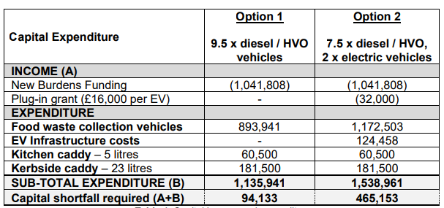

Residents Parking Zone – Stowmarket
Mid Suffolk are proposing to support Suffolk Council in funding a design phase of residents parking solution in Stowmarket. Problems have continually increased largely due to the increase of use of the rail travel / commuters looking to avoid high costs of parking at the station.

